* **Memory Management**

In this, you will learn:

* What is Memory Management?
* Why Use Memory Management?
* Memory Management Techniques
* Contiguous and non-contiguous allocation
* Logical and physical memory

**Definition**

main memory is divided into two types of partitions

1. **Low Memory** - Operating system resides in this type of memory.
2. **High Memory**- User processes are held in high memory.

Memory is divided into different blocks or partitions. Below are the various partition allocation schemes :

* **First Fit**:
* **Best Fit:**
* **Worst Fit:**
* **Next Fit:**

## Why Use Memory Management?

## Memory Management Techniques

### Single Contiguous Allocation

### Partitioned Allocation

### Paged Memory Management

### Segmented Memory Management

**What is Contiguous and Non-contiguous memory allocation-**

* 1. **Contiguous Memory Allocation :**

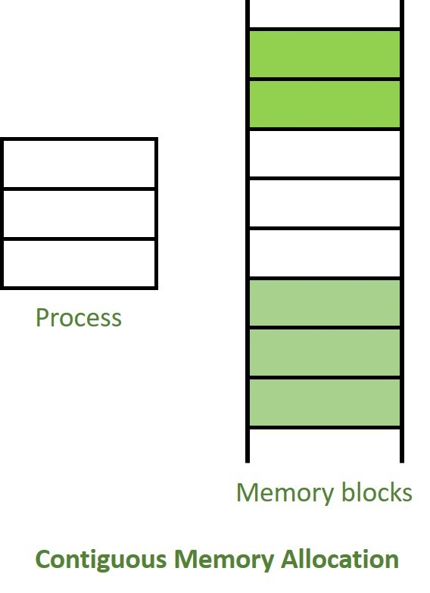

* 1. **Non-Contiguous Memory Allocation :**

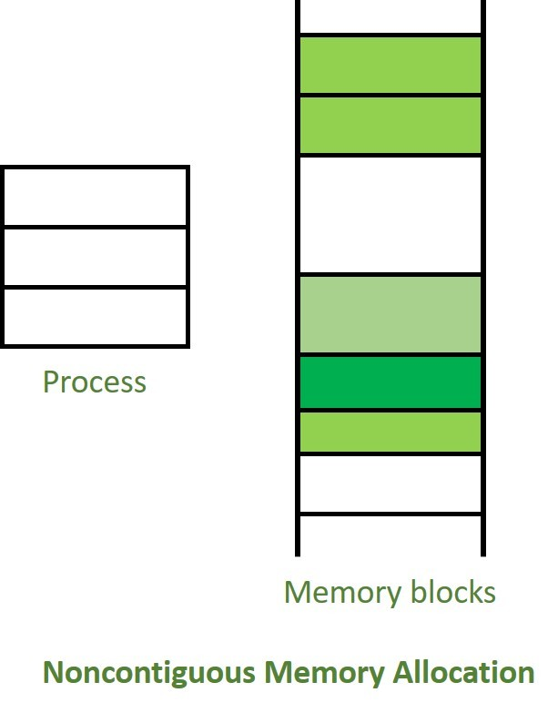

**Difference between Contiguous and Non-contiguous Memory Allocation**

**Logical and Physical Memory (Address in Operating System)**

* **Logical Address** is generated by CPU while a program is running. (Virtual)
* **Physical Address** identifies a physical location of required data in a memory.

**Differences Between Logical and Physical Address in Operating System**

**(MCQ-1 mark, 2 mark)**

**Prof. Ravindra Ingle MCA Department JSPM NTC pune.**